|  |
| --- |
| Hempel A/S |
| CRM Manual |
| Answers on your most frequent questions about CRM |

|  |
| --- |
| Commercial Support - Europe  6/11/2014 |

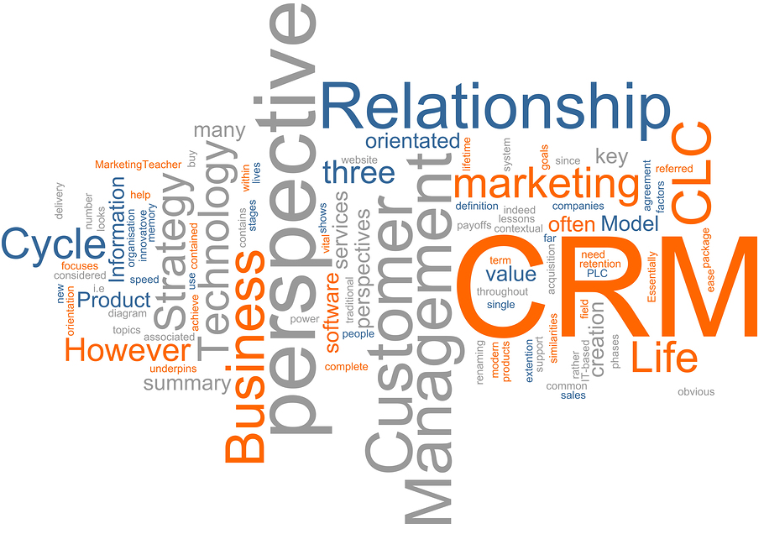

Contents

1 How to Access CRM 2

2 Definitions and how to create account/contact/project 3

2.1 Lead 3

2.2 Account 4

2.3 Contact 6

2.4 Opportunity 7

2.5 Customer Classification (Europe) 8

3 How to Create a View 9

4 How to send Merged E-mail with attachments in the CRM 13

5 How to add Contacts and Accounts to Marketing lists 15

6 Merging and Deactivating of duplicates 19

7 Activities in CRM 21

8 Bulk edit of data (export to Excel and re import to CRM) 23

# How to Access CRM

There are 2 ways to start working with CRM:

1. Via Outlook: you can use the shortcut at the bottom or at the left side

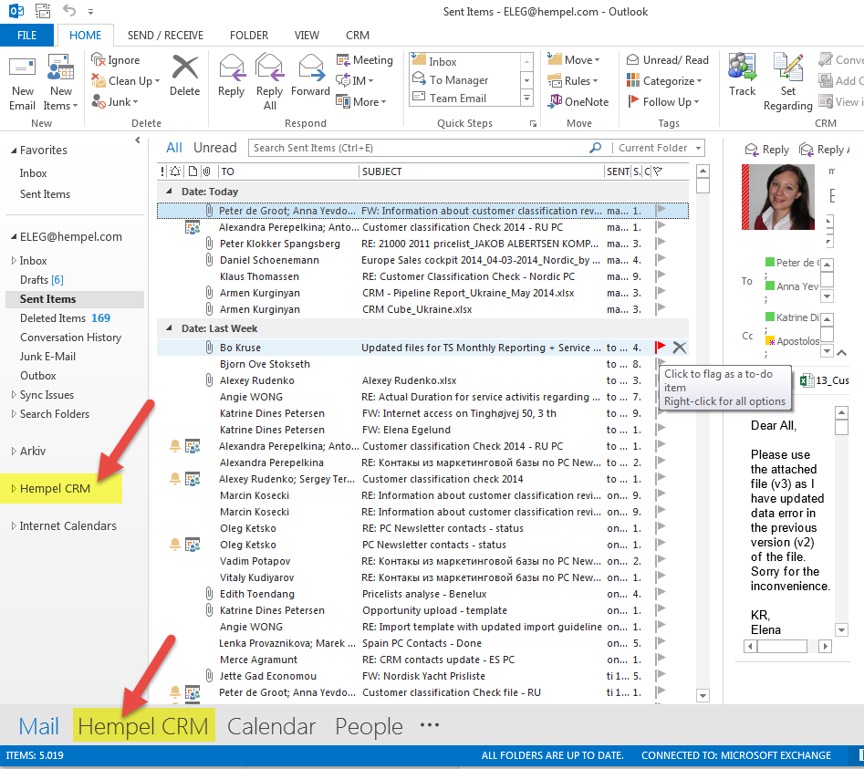

1. Via web browser: just type “crmlive” in the web address field and click “enter”

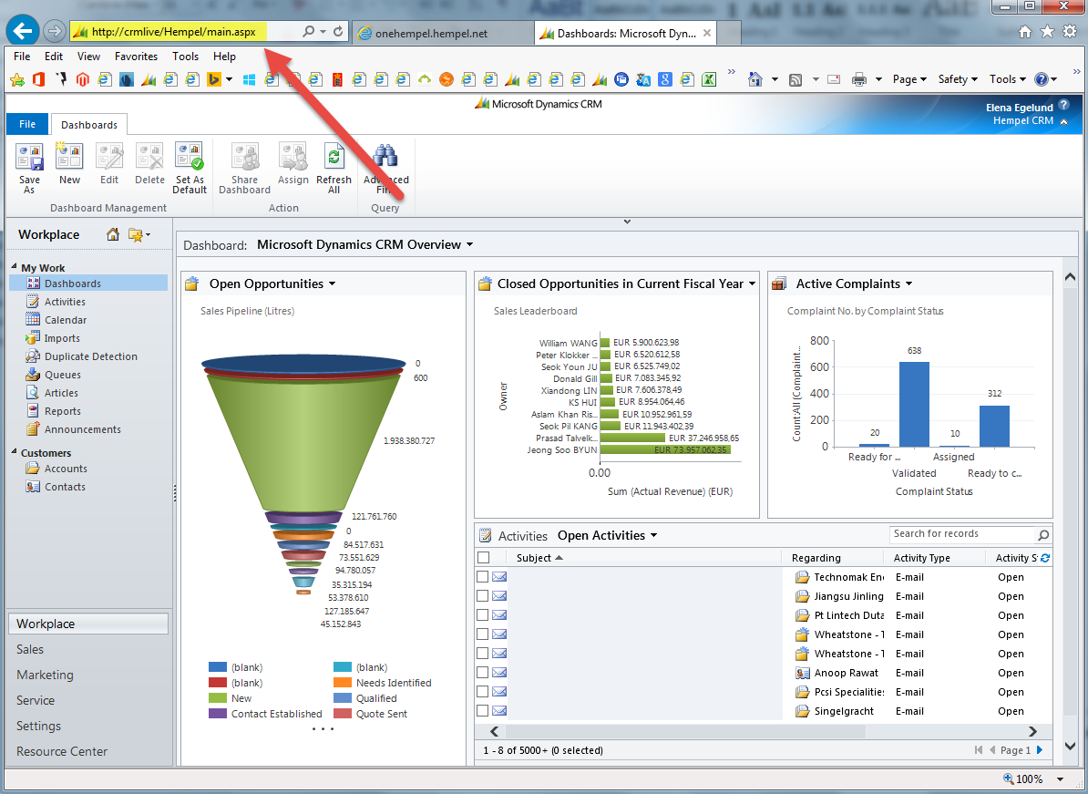

# Definitions and how to create account/contact/project

Data in the CRM system is mainly organized by the following 4 “entities”: Leads, Accounts, Contact and Opportunity. Before creating a new record in CRM (contacts, projects, accounts) please check if it is not already created by your colleagues.

## Lead

**A Lead is a potential unqualified target for sales meaning a potential Customer (Account) or** **Opportunity.** So a New Lead is a customer or project where we have still not confirmed if there is any short or long term interest. An example could be a list of customers that we buy from e.g. research companies (procured marketing lists) or projects a sales guy has seen on the road or read about in the press. Other Lead sources could be Contacts from trade show, respondents to surveys, etc.

To create a lead click on “New” in the “Leads” section:

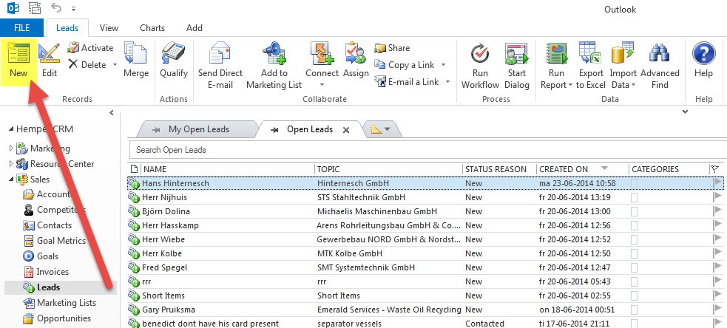

Please note, that all fields, which are marked with a red star, are mandatory to be filled out.

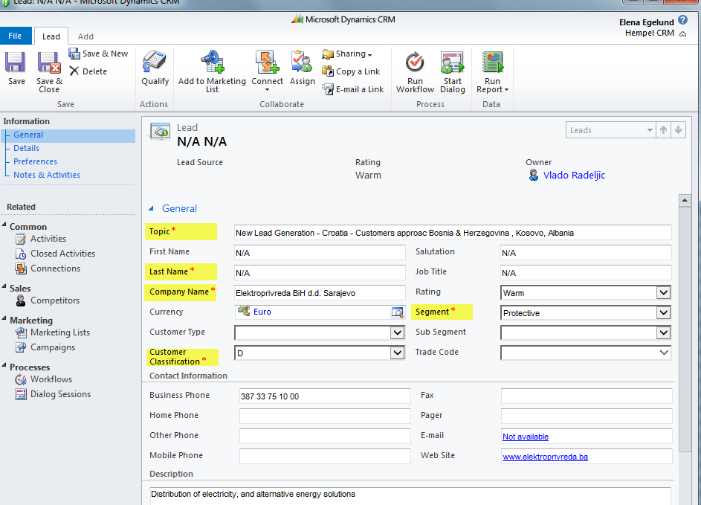

## Account

**An Account is a company or a group of companies.** An Account is a legal entity or well-defined sub-organisation of a legal entity (like a division or a vessel). Accounts can be: Buying Account, Owner, Specifier, Applicator, Engineer, Consultant, Distributed customer or Vessel. An Account can be part of a Parent Account (like vessel fx), which is an entity owning several accounts.

To create a new account click on “New” in the “Accounts” section:

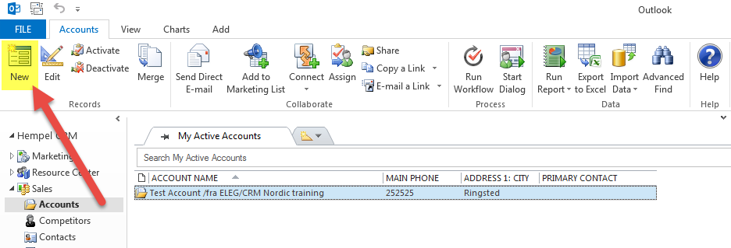

|  |  |
| --- | --- |
| **Naming guidelines: ACOUNTS** | |
| **Name Field (Link to AX):**  Entries marked (DW) are coming from AX. |  |
| **Name Field (No Link to AX):**  All entries must be made using capital letters. |  |
| **Phone/FAX Number:**  🡪No spaces between city codes and phone numbers for both phone and fax.  🡪-X for from/to numbers |  |
| **Customer’s Sales Potential:**  Apart from the mandatory fields (*) always fill in: Potential Gross Profit  Potential Volume (L) is an estimation of customer’s paint consumption in terms of litres per year, which includes what customer buys from our competitors.  Potential Revenue = Potential Volume (L) x Hempel’s ASP  Potential Gross Profit = Potential Volume (L) x Hempel’s GP/L |  |
| New Account, following fields must be filled out:  🡪Potential Volume  🡪Potential Revenue  🡪Potential Gross Profit  🡪Primary Contact  🡪Sales Potential Classification  🡪Segment  🡪Country  🡪Address Type  🡪Customer Acquisition  🡪Customer Penetration  Fields marked with a red star are mandatory. |  |

## Contact

**A Contact is an individual that works for or is associated with an Account (customer).** A contact should always be linked to an Account. A contact must only be listed once even though it is active with more sales people, Accounts, Opportunities etc.

To create a new contact click on “New” in the “Contacts” section:

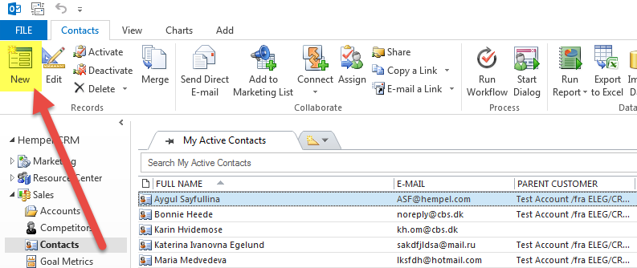

|  |  |
| --- | --- |
| **Naming guidelines: CONTACTS** | |
| **Name Fields:**  🡪Salutation. Mr./Mrs./Cpt./Dr.  🡪Names: Capital first letter, small rest  🡪Job Title: Always fill in full title. No abbreviations.  🡪Phone/Fax: Same format as described under “account”  🡪E-mail |  |
| **Address: fields to be filled out:**  🡪Street 1  🡪Zip/Postal Code  🡪City  🡪Country/Region  🡪Street 2 and Street 3 are only used if contact has 2nd and 3rd address within the same city. Normally these fields should be empty |  |

## Opportunity

**An Opportunity is a project, dry dock or a contract (i.e. an annual supply contract) with a start and finish date.** When possible, an Opportunity must belong to the BUYING ACCOUNT. If other Accounts are relevant for an Opportunity (i.e. a Specifier or Sub-contractors) these are linked to the OPPORTUNITY via the function “relationship”.

To create a new Project click on “New” in the “Opportunities” section:

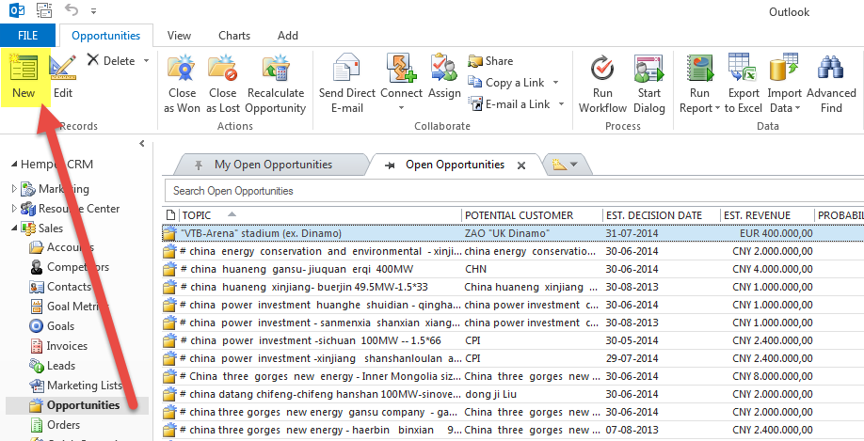

|  |  |
| --- | --- |
| **Naming guidelines: OPPORTUNITIES** | |
| **Header:**  🡪 Entries should always be in English unless the user does not know how to write it in English.  🡪 If local language is required for some internal reporting “Topic Local Language” can be used for (i.e. Spanish version).  **Marine:**  **NB:** “NB” + number of vessels (perhaps with options) + vessel type + vessel size in DWT + name of owner + perhaps scope (full ship, outer hull, etc.) + perhaps key product  **Example**: “NB 4+2 Bulk 60 K DWT for Mamaras, excl cargo” **or** “NB 10 Container 120 K DWT for Maersk Line Full Ship”  **DD:** “DD” + vessel name + perhaps main antifouling or FR system  **Example:** “ DD Britta Maersk with Hempaguard X7  **SS:** “SS” + company name + period + type of contract  Example: “SS Maersk 2014-15 Exclusive Supplier”  **Protective:**  Project name/object name + new or maintenance + size  Example: “Anholt Windfarm phase II, 40x4,5MW” or “ Sochi Football Stadium” or “Distributor XXX” |  |
| **Forecast Information,**  **fill in all forecast information fields:**  🡪Est. Revenue  🡪Est. Decision Date  🡪Pipeline Phase  🡪Probability (chances to win project)  🡪Rating  🡪Est. Volume (L) |  |
| **Expected Delivery:**  🡪Expected delivery fields always to be filled in  🡪In case a DD is postponed, add a future delivery date (+Cold in the field “Rating”). Do not close the opportunity as it will appear as “Lost”  🡪If you don’t know the delivery pattern – select “flat”  🡪If delivery is in another country than you are located in – fill out the “Delivery country” |  |
| **Notes & Activities**  🡪Always attach quotation on the opportunity (whenever available)  🡪Important E-mails should also be attached to the opportunity  🡪 All linked e-mails can be found under “Closed Activities” |  |

## Customer Classification (Europe)

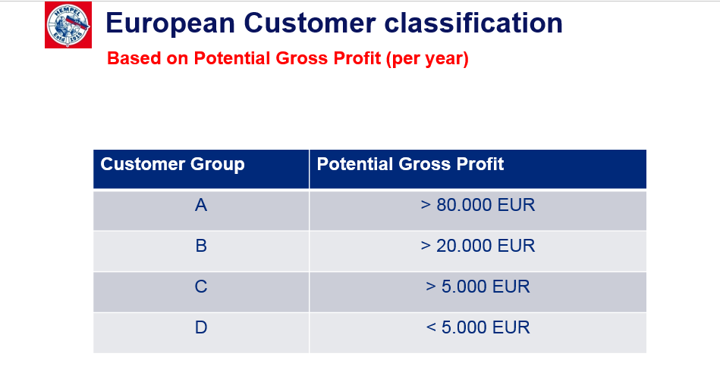

# How to Create a View

1. Pick the view you want to use as starting point for your view (e.g. All Accounts or Open Opportunities).
2. Click on “Advanced Find” (in the Add-Ins tab in Outlook).

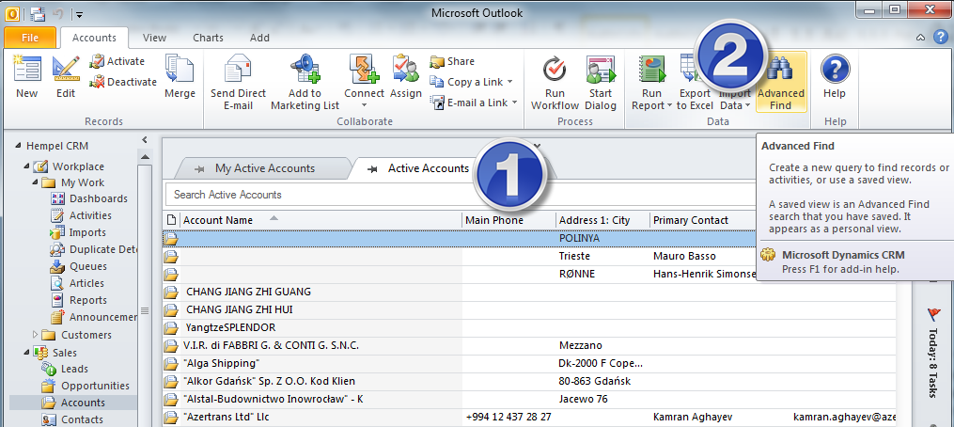

1. The following window opens up. To start creating your view please save it as a separate view under a new name, it should be different from standard view names.

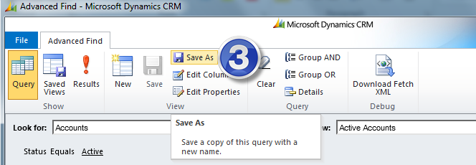

1. To prepare the filter(s) for the view please click on “Details”.
2. Then you need to change the view to what should be the data you want to filter. Like in this example All Accounts. It is often a good idea to use the views that include All as this gives you all the data you have access to. Then you click “select” to add your filter. Here you can pick any of the fields on the (in this case) Account.

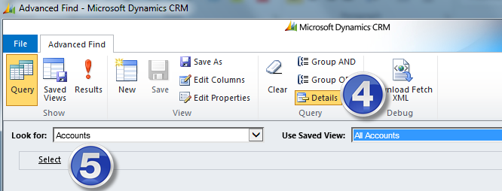

Filters below will give us all Active Downstream customers, which belongs to Jordi Borrell . This way you can combine different filters to see exactly what you need. Please note that if customer is from Downstream, but it has no data in the sub-segment field, it will not appear in this selection.

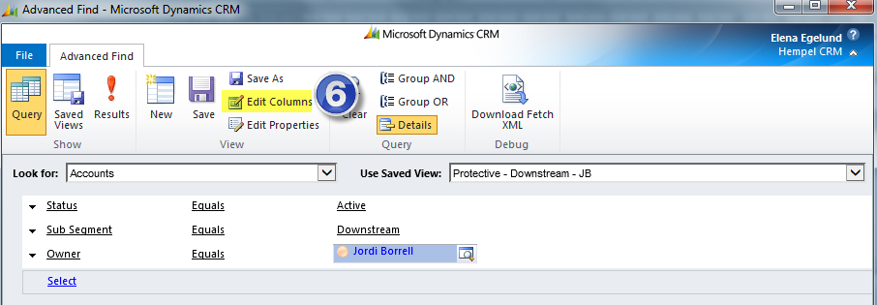

1. To add or delete columns click “Edit Columns” and the following below window opens. By adding columns you can create extensive Excel reports and it gives you access to all information on the different entities. If the field exists on the Account, Opportunity, etc. you can make reports on it and use it as filter.
2. Use the green arrows to change the order of the columns if you wish to and click “add columns” if needed. Then you will have the following choice.
3. Here you will have the option of creating a column for each field that exist on the Account (the same will be the case if you try to do a view for opportunities, Contacts, etc.)
4. You can also create a column for a field on other entities related to an Account by clicking where it says “Account” and selecting “Originating Lead (Lead)” fx.

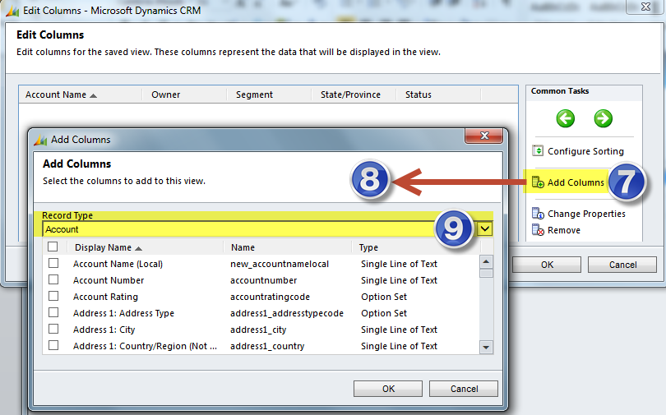

1. If you want to remove columns the following window opens. You need to mark the header of the columns you wish to remove and then click on “Remove” button.

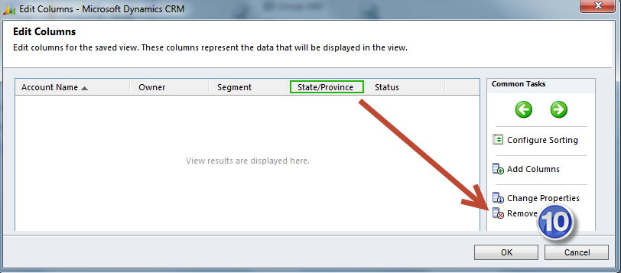

1. To activate the view you click “Saved views” and in the new opened window you can click on “Activate” to activate the view, “Deactivate” in order to deactivate it or delete the view by clicking on “Delete Saved View”.

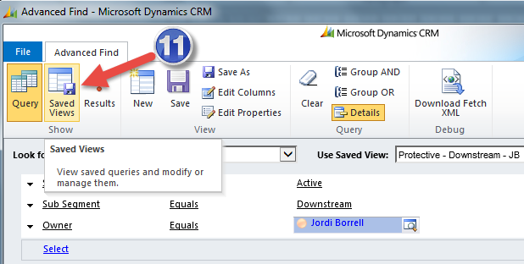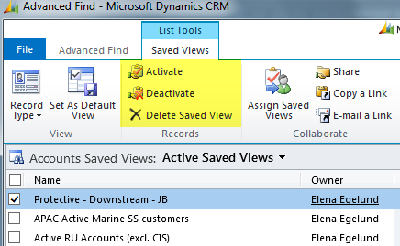

1. If you wish to share this view with a colleague then mark the view, click on “Share” and “Add User/Team”. In the new window you need to find a needed colleague and give him/her the permissions to the view that you want to share. It is possible to share a view with a team (fx team “Spain” means all CRM users from Spain).

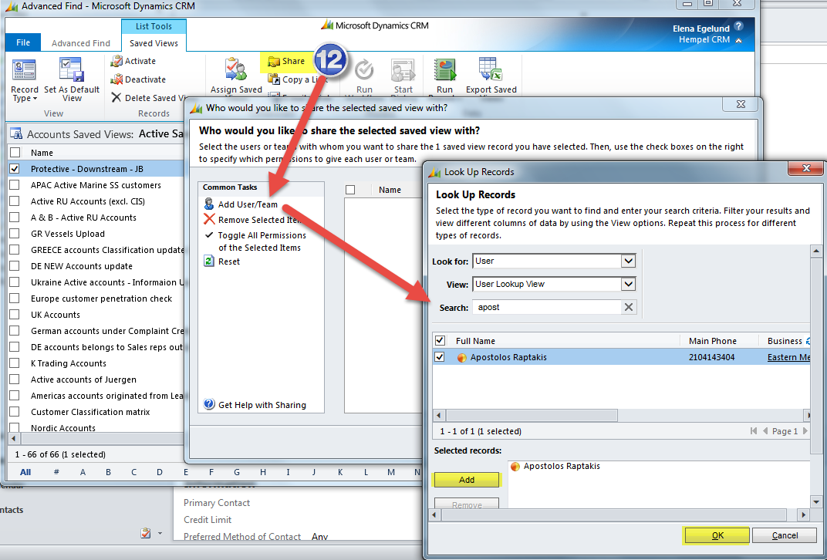

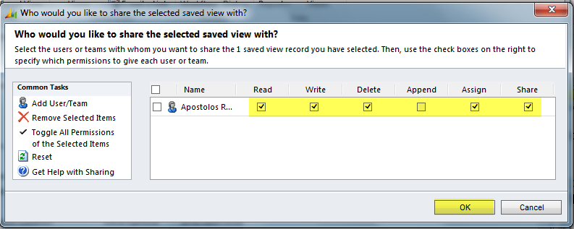

1. You can export the data from your view to Excel. To do that you need to click the Excel icon and then chose what kind of export you want.

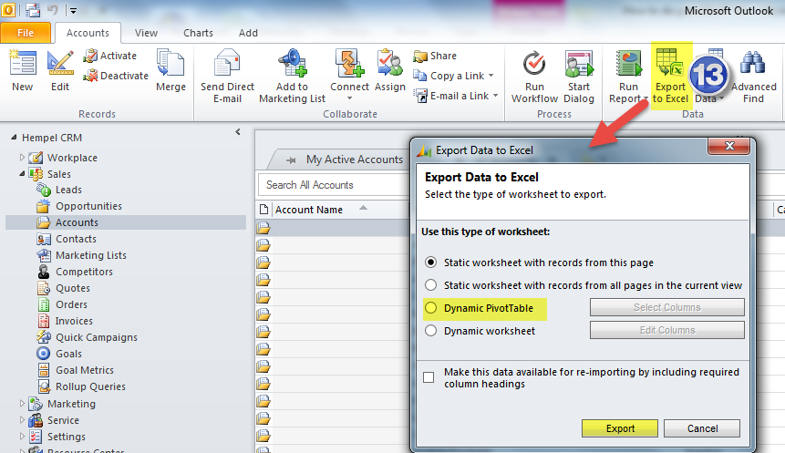

If you chose a “Dynamic Pivot Table” or “Dynamic worksheet” the Excel file will update with “fresh” CRM data every time you open the sheet. This way you don’t have to recreate the export every time. This is especially nice if you want to follow up on fx status of your opportunities or customer portfolio in CRM.

# How to send Merged E-mail with attachments in the CRM

1. Find contacts, who you would like to send the merged e-mail to

On the screenshot below I have searched for “Test account” in the active accounts view to find my contacts and marked two of them.

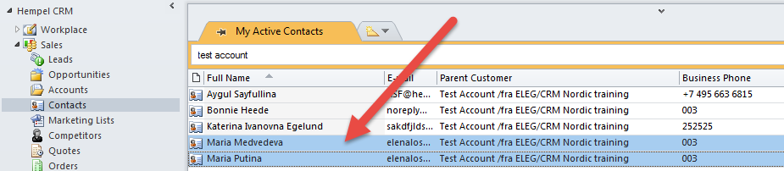

1. Change the tab from “Search” to “Add” and click on “Mail Merge”

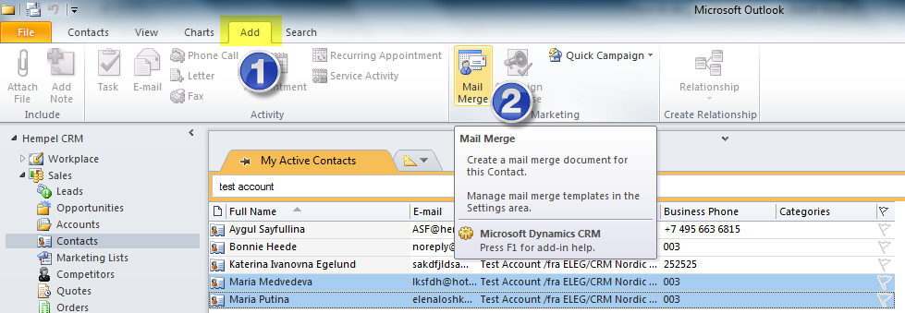

1. In the next coming windows (see the screenshot below) please click on “Download” and “OK”

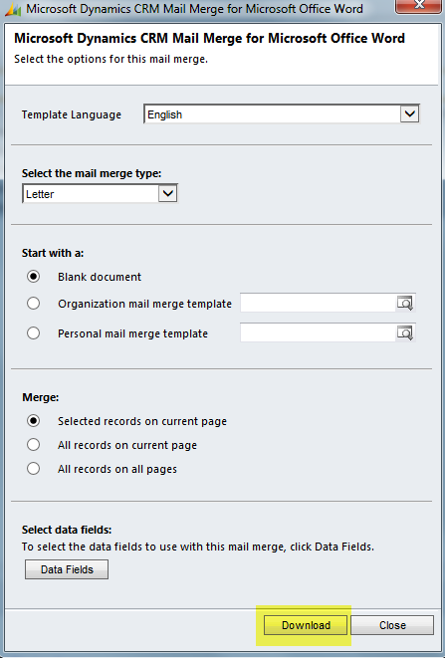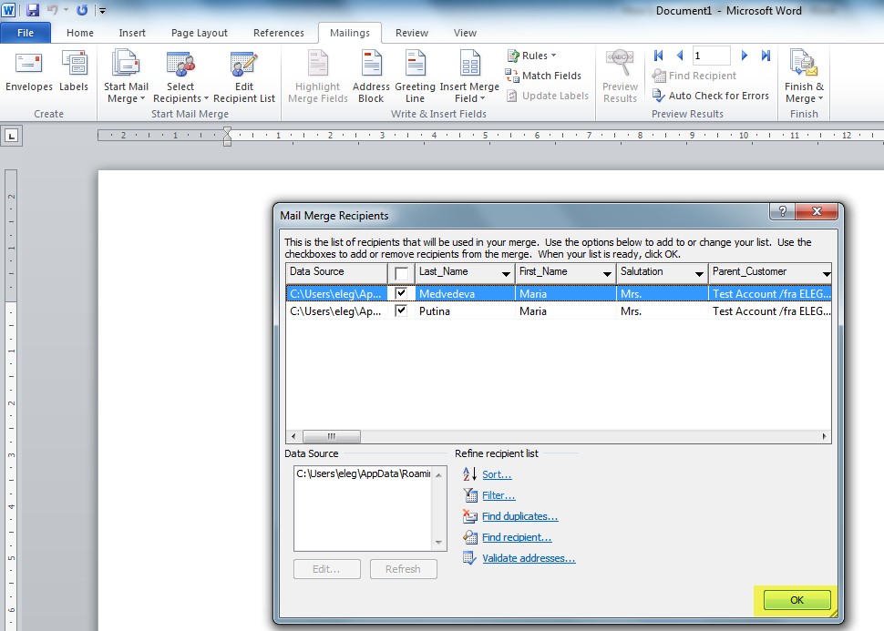

1. In the opened Word document you can write your e-mail and then click on “Finish and Merge” and “Send E-mail Messages”.

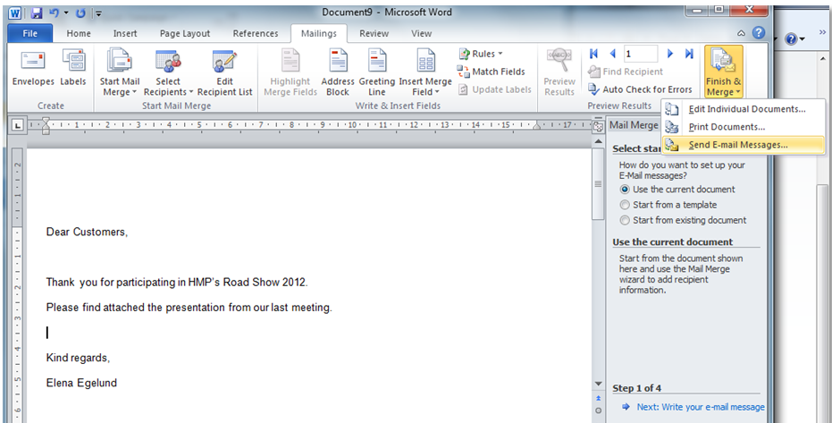

1. In the “Merge to E-mail” window please type your subject line and click “ok”

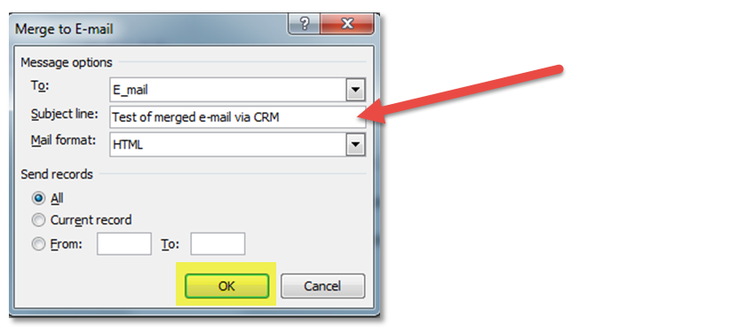

1. In the next window select “Create Microsoft Dynamics CRM activities” if you would like CRM to keep e-mails in the “closed activities” for you.

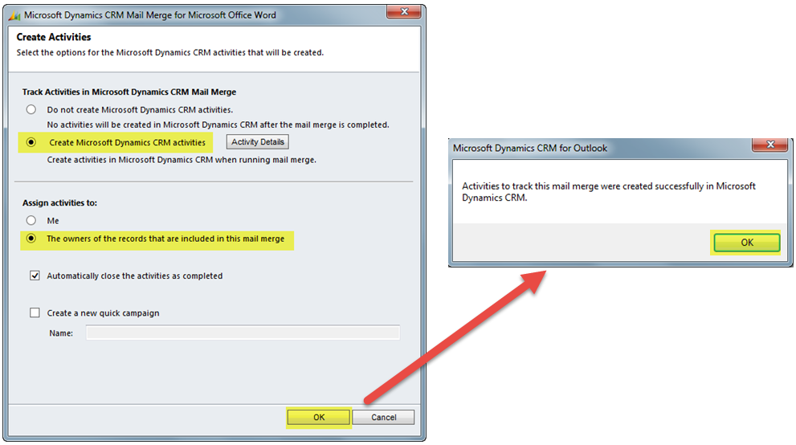

# How to add Contacts and Accounts to Marketing lists

A Marketinglist is a list of customers or persons working for customers, which should receive certain kind of information e.g. Newsletter, Christmas Card and invitation to seminars or cultural events. The owner of the Contact/Account can add his/her Contacts/Accounts to the different Marketinglists, which has been created by the owner, Marketing or SuperUsers.

The below view (Europe and Nordic Marketinglist) has been created for you in order to make it easier to get a quick overview of Marketinglists relevant for you. If you believe a Marketinglist is missing, please contact your SuperUser.

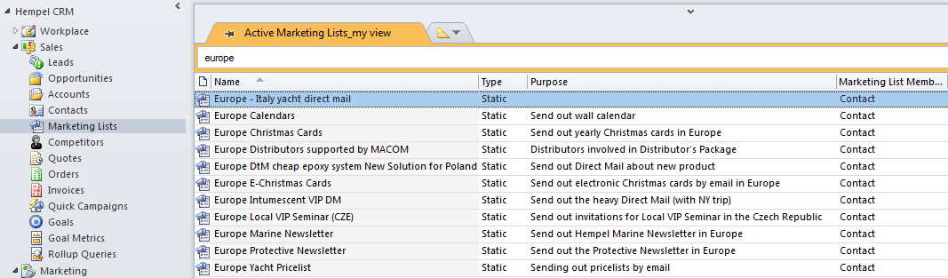

There are 2 ways to add a Contact or Account to a Marketing list: A) from inside the Contact or Account, B) from the Contact/Account list.

1. Add a Contact/Account to a Marketing list from inside the Contact/Account.
2. Open the Contact/Account you want to add to a Marketing list and click on “Marketing list”

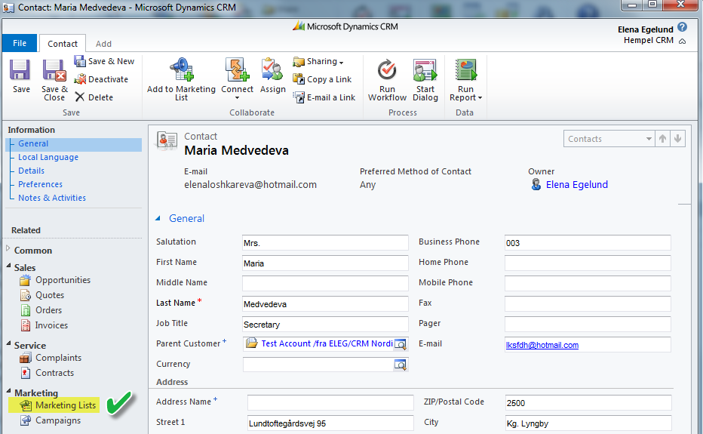

1. You now see the list of Marketing lists the Contact/Account is already added to (if any). In the example below the contact is added to 3 marketing lists.

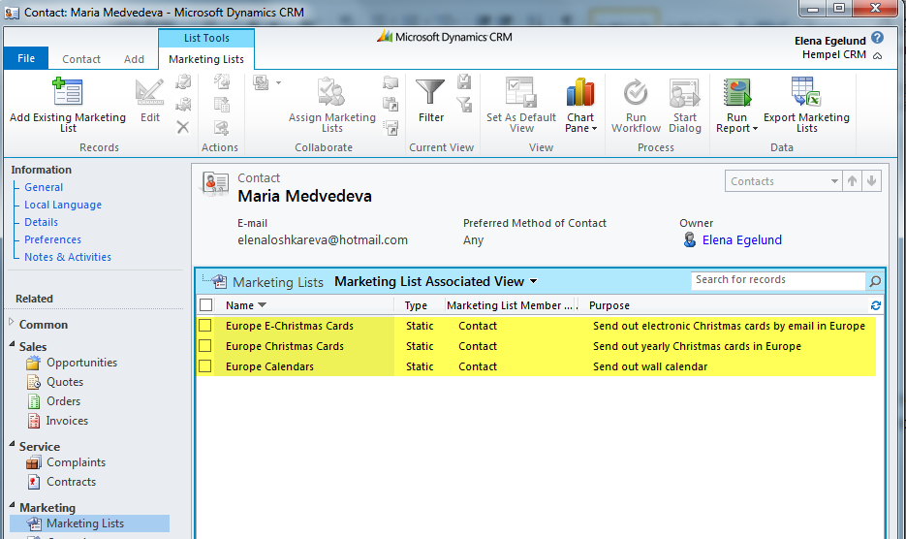

1. If you want to add to a new list, click on “Add to Existing Marketing list”, select needed marketing list, click on “Add” and “Ok”

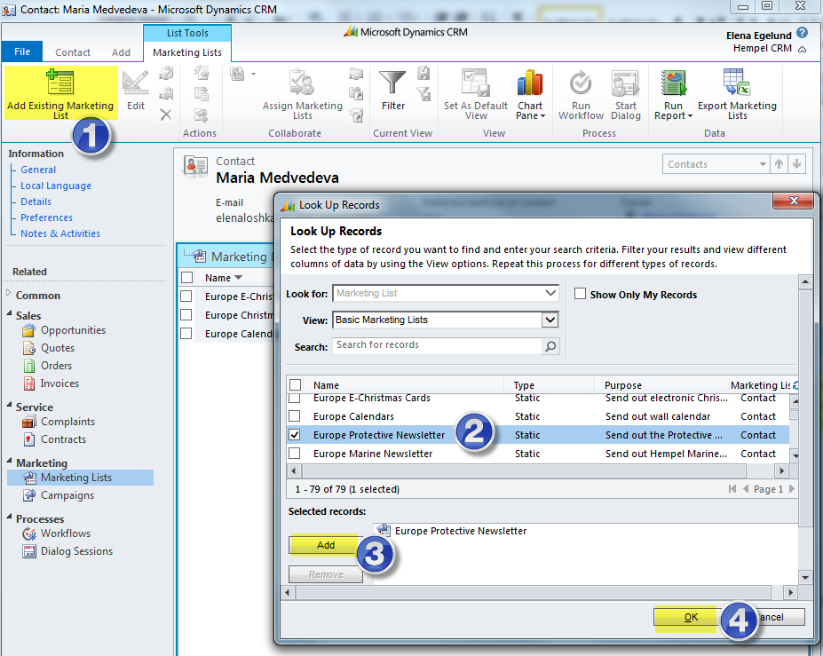

1. If you want to remove your contact from a marketing list, select the marketing list and click on “Remove” button

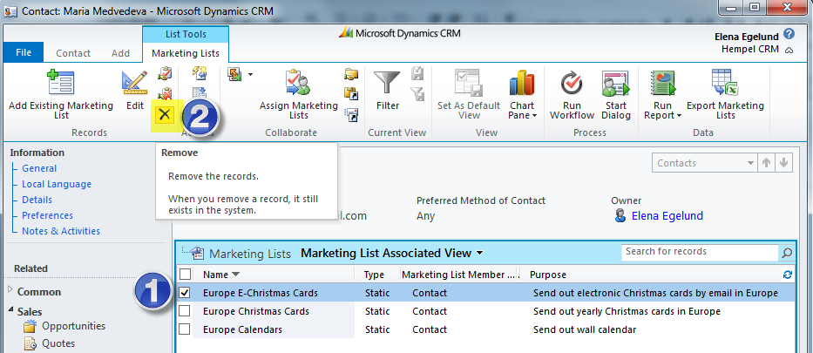

1. Add a Contact/Account to a Marketing list from a Contact/Account list
2. Go to the Contact/Account list and mark the Contact(s)/Account(s) that you want to add to a Marketing list
3. Click on “Add to Marketing list”
4. Now chose the Marketing list you want to add your Contact/Account to or search for a Marketing list (“search for records”)
5. Confirm the selected marketing list and click on “Ok”

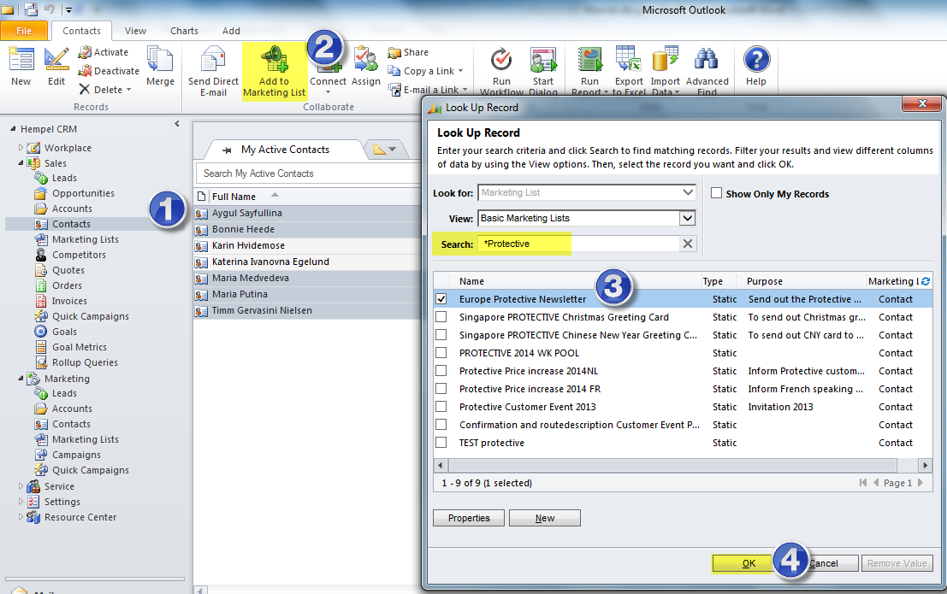

# Merging and Deactivating of duplicates

When working with account records in CRM, you might notice that the same record appears twice or even more times. This can happen fx because one contact (or account) was created several times by different sales reps.

In order to deactivate the record please mark it and click on “Deactivate” button on the “Contacts” ribbon.

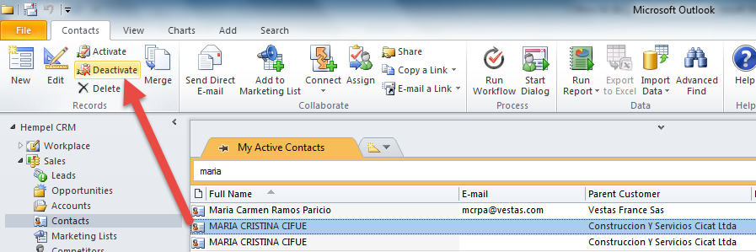

You can use the merge functionality to merge two records, so as a result you will have only one active record, and the second one will be deactivated automatically. To merge please select 2 records and click on “Merge”.

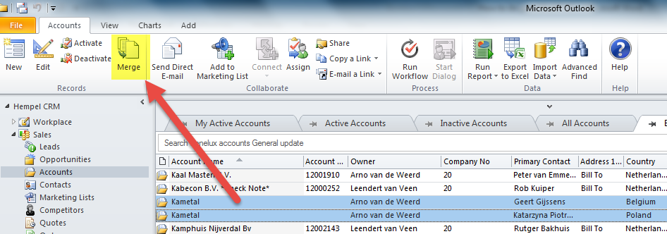

When you click on “Merge” button you will be prompted with following below window using which you can choose what information you will save on the Master record, which is going to be left after merging:

1. You need to define the master record which is at the end will remain active and other will get deactivated.
2. Select what information should be saved on the Master record (on the example below Primary contact, Phone and address information are selected from the second record).
3. Confirm merging and click on “Ok”.

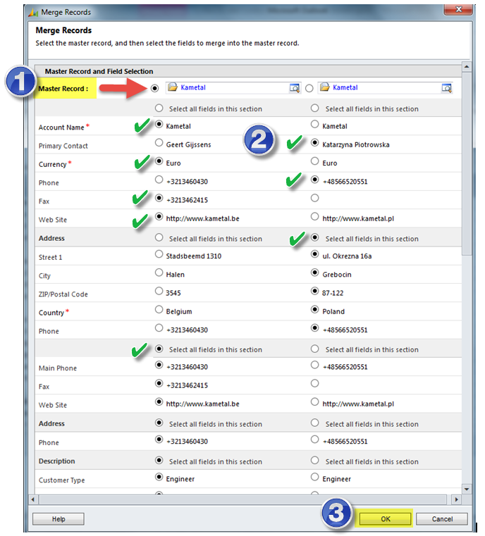

After you click ok, the system will deactivate the old account and transfer the details from subordinate record into master account, and the following below message will appear.

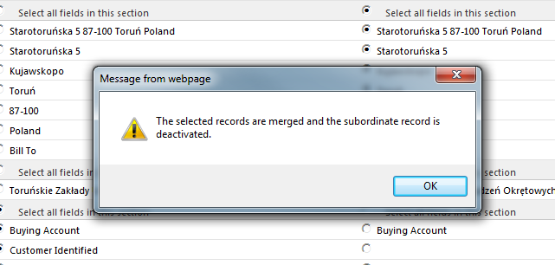

# Activities in CRM

There are following activities available in CRM: E-mail, Task, Appointment, Phone Call, Letter, Fax, Recurring Appointment and Service Activity. First three are mainly used. Please note that CRM is synchronised with Outlook, therefor all tasks, appointments and of course e-mails you will find both in CRM and in Outlook.

All activities can be used for all entities in CRM, but it mostly relevant for Accounts, Contacts and Opportunities.

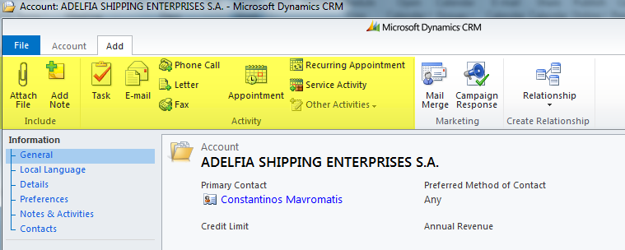

If you send a quotation fx to a customer you can send an e-mail directly from CRM regarding needed opportunity:

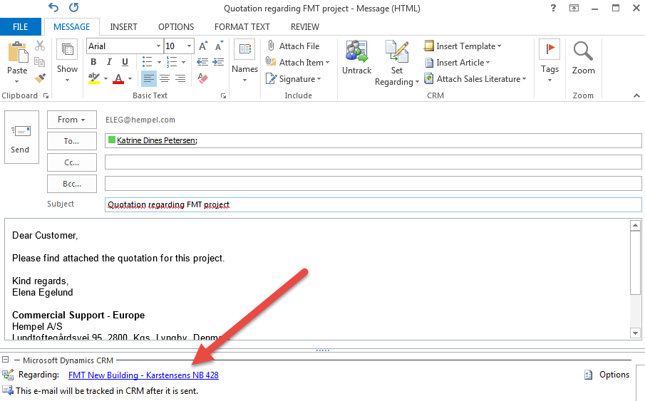

If you want to make a reminder for yourself to fx remember to follow up on a project – create a task in CRM and it will appear in the Outlook task list. You will get a reminder 15 minutes before the time, which you set in the task.

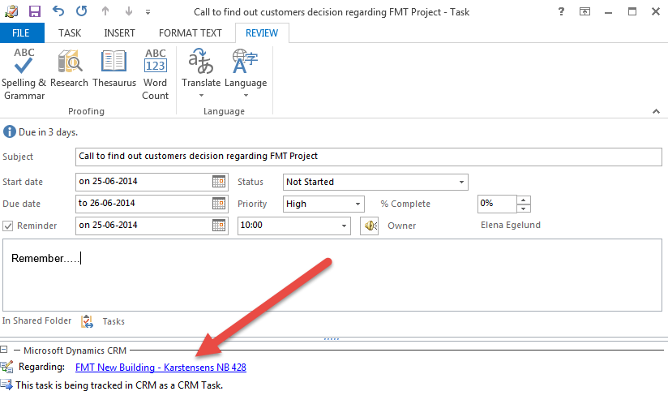

Plan your meeting directly from CRM and you will find them both in CRM and in your Outlook calendar. This way you always have a history of your important meetings with the customer.

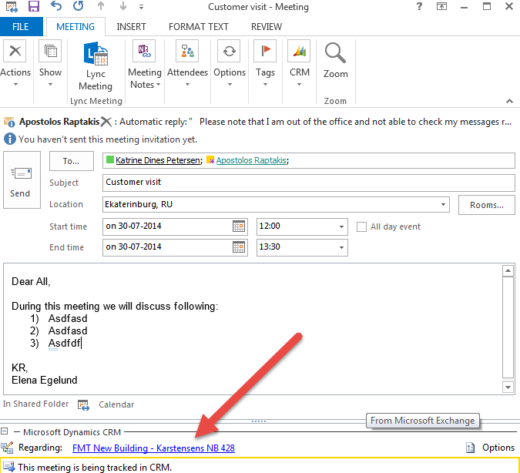

# Bulk edit of data (export to Excel and re import to CRM)

If you have large data updates to do you can now do it by exporting the incomplete data set to Excel. Then edit the data in Excel and finally re import it directly to CRM. This way you can update any kind of information about contacts, accounts or opportunities.

Before you start using bulk editing you need to create a view, which includes fields you are planning to update. To prepare the view please see section 1 in this document. To start bulk editing of data please follow the steps:

1. Go to the relevant view (in the example below it is “Russia accounts General update)
2. Click “Export to Excel”
3. In the opened window select “Static worksheet with records from this page” and remember to tick the box “Make this data available for re-importing by including required column headings”
4. and click “Export”

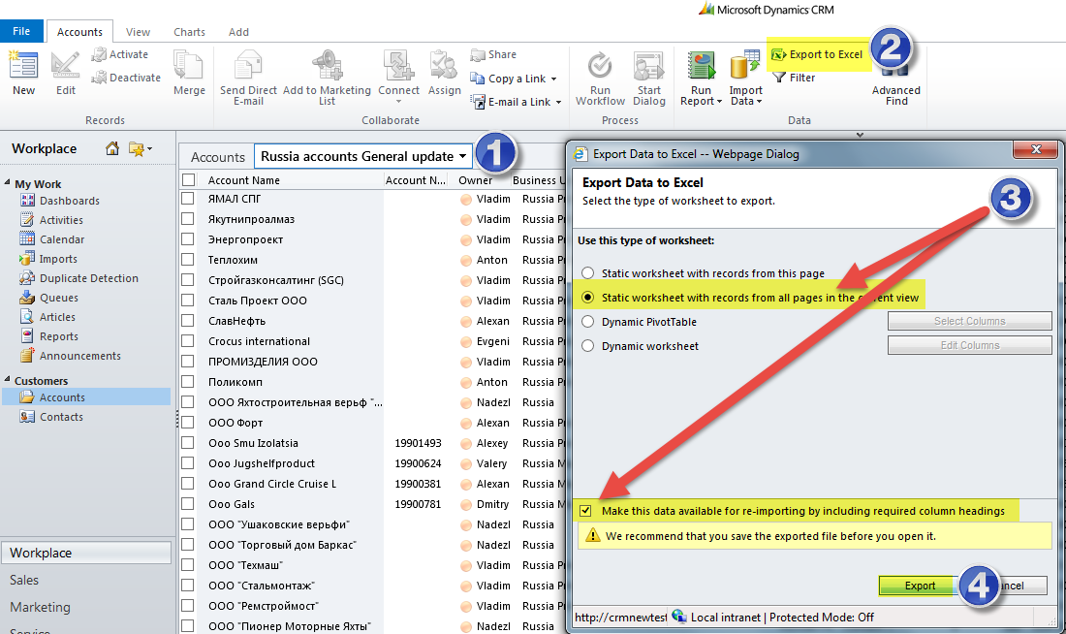

1. Then you must save the document and click “Open” in the next window

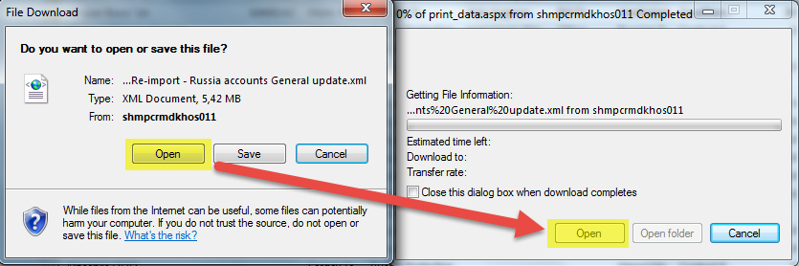

1. Now the Excel sheet opens up and you can start editing the data in Excel (please do not change cells, which are marked in blue, and do not add extra columns)
2. Save the Excel sheet when you are finished with updating, close it and the go back to CRM.

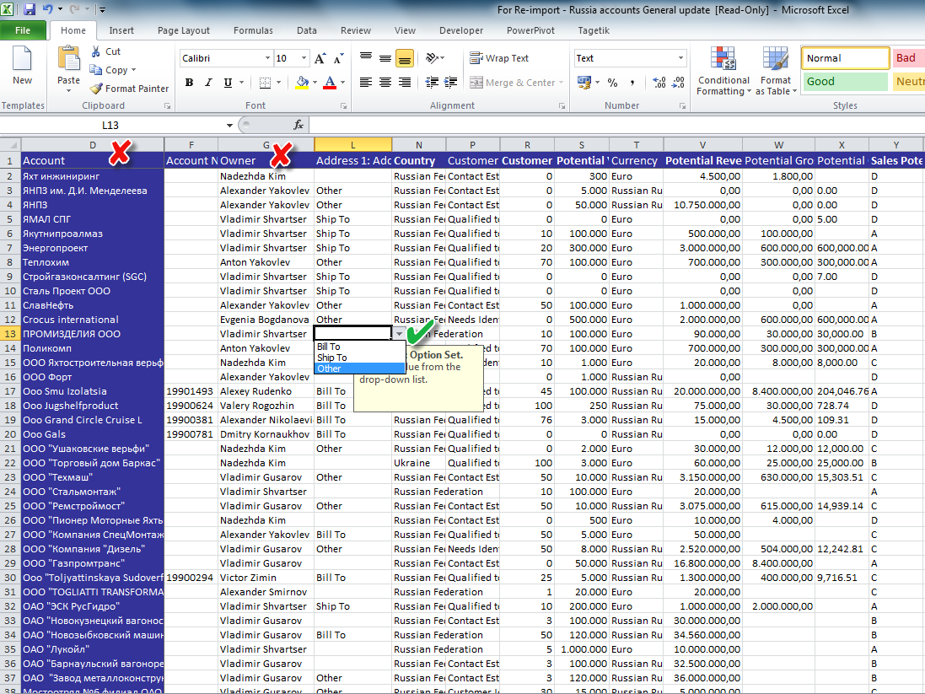

Next part is importing of the Excel file with updated data back to CRM:

1. Click on “Import Data”
2. Browse to find the file you saved earlier on your pc
3. Then click “Next”

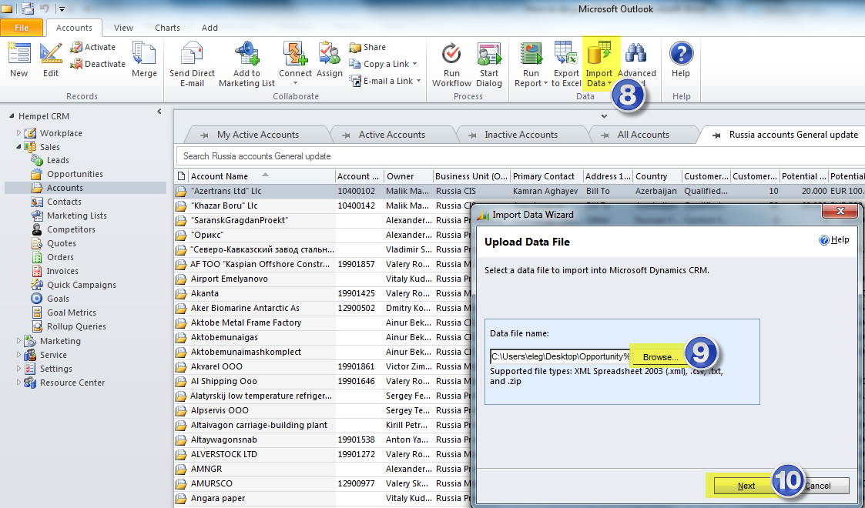

1. In the next window click on “yes” for allow duplicates and on “Submit” button

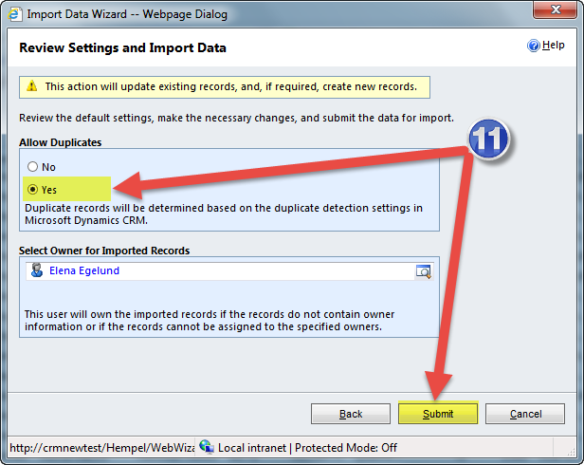

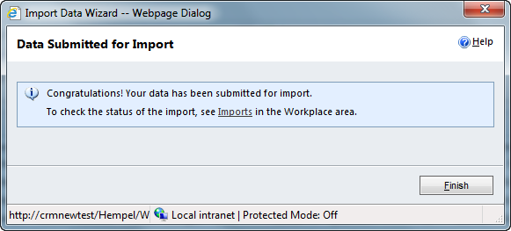

Please note that export/import of excel file should be done **THE SAME DAY**, otherwise the import will not work.